2)

**A)** SELECT SalesOrderID, LineTotal

, MAX (LineTotal) OVER (PARTITION BY SalesOrderID) AS MAX

, MIN (LineTotal) OVER (PARTITION BY SalesOrderID) AS MIN

, AVG (LineTotal) OVER (PARTITION BY SalesOrderID) AS AVG

FROM [Sales].[SalesOrderDetail]

WHERE SalesOrderID IN (43659,43664)

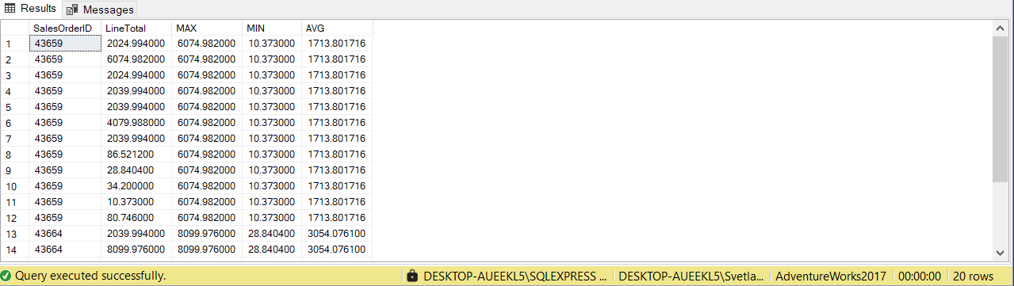

**B)**

SELECT TOP 1 BusinessEntityID, LastName, FirstName, SalesYTD, TerritoryGroup

, UPPER (LEFT(LastName, 3)) + 'login' + COALESCE(TerritoryGroup, '') AS Login,

RANK() OVER (ORDER BY SalesYTD DESC) AS Rank

FROM Sales.vSalesPerson

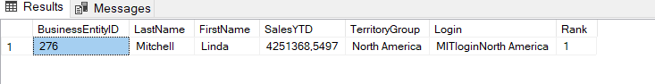

SELECT TOP 1 BusinessEntityID, LastName, FirstName, SalesLastYear,TerritoryGroup

, UPPER (LEFT(LastName, 3)) + 'login' + COALESCE(TerritoryGroup, '') AS Login,

RANK() OVER (ORDER BY SalesLastYear DESC) AS Rank

FROM Sales.vSalesPerson

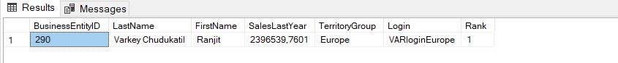

**C)**

SELECT

CASE

WHEN CAST (DATENAME (weekday, DATEADD (day,1, EOMONTH (GETDATE ()))) AS varchar) NOT IN ('Saturday', 'Sunday') THEN DATEADD (day, 1, EOMONTH (GETDATE ()))

WHEN CAST (DATENAME (weekday, DATEADD (day,2, EOMONTH (GETDATE ()))) AS varchar) NOT IN ('Saturday', 'Sunday') THEN DATEADD (day, 2, EOMONTH (GETDATE ()))

ELSE DATEADD (day,3, EOMONTH (GETDATE ()))

END

